Hot Shower

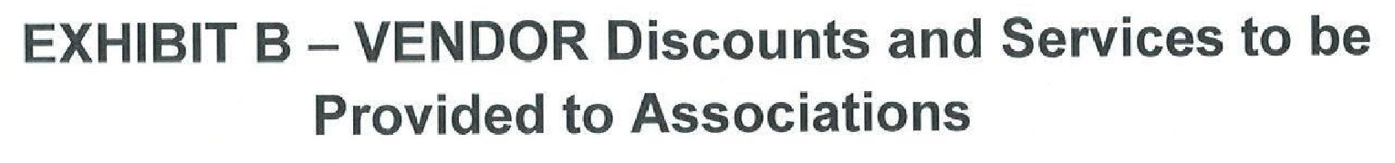

- Any new buildings where we have not previously worked, will receive a 25% discount on their first invoice.
- We provide affordable water pressure restoration to baths, kitchens and entire properties. By restoring water pressure, you can avoid replacing hot water pipes and save money and avoid messy projects.

