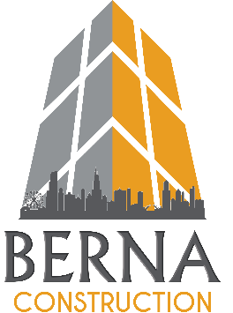

Exhibit B – Vendor Discounts and Services to be Provided to Associations.

We offer 24/7, full service plumbing and HVAC services as well as site utilities. Anything that we demolish, we will repair. This includes framing, drywall, taping, painting, tile replacement and so on. We are a licensed General Contractor as well as a licensed plumber and HVAC.

Clients using us as their preferred plumber and whose building systems we maintain regularly will be discounted on any emergency backups and will only be charged the regular hourly rate.

10119 Roosevelt Rd, Westchester, Illinois 60154
Phone: (312)985-9400 Email: office@bernaco.com

